

UNIVERSITY OF PETROLEUM AND ENERGY STUDIES DEHRADUN

Cyber Threat Intelligence Lab
Assignment 1

MTECH-COMPUTER SCIENCE ENGINEERING
CYBER SECURITY AND FORENSICS

Name: Jigesh Sheoran SAP ID: 590025428

OBJECTIVE:

- Understanding system and application logs is crucial for troubleshooting system issues, identifying security threats, and monitoring system health. Most logs have levels (e.g., Info, Warning, Error). Focus on higher levels for troubleshooting and security monitoring. Use tools' built-in filtering or search functionalities to narrow down log entries. Look for patterns or events occurring around the same time that might be related. If you find an error message you don't understand, search online for explanations and solutions

- Windows OS Logs

Example 1: Identifying Application Crash

- Open Event Viewer (build-in tool), search for it in the Start Menu.
- Expand Windows Logs and select Application.
- Look for events with a Critical or Error level. These might indicate application crashes.
- Double-click the suspicious event to see details. The description will often point to the source of the issue.

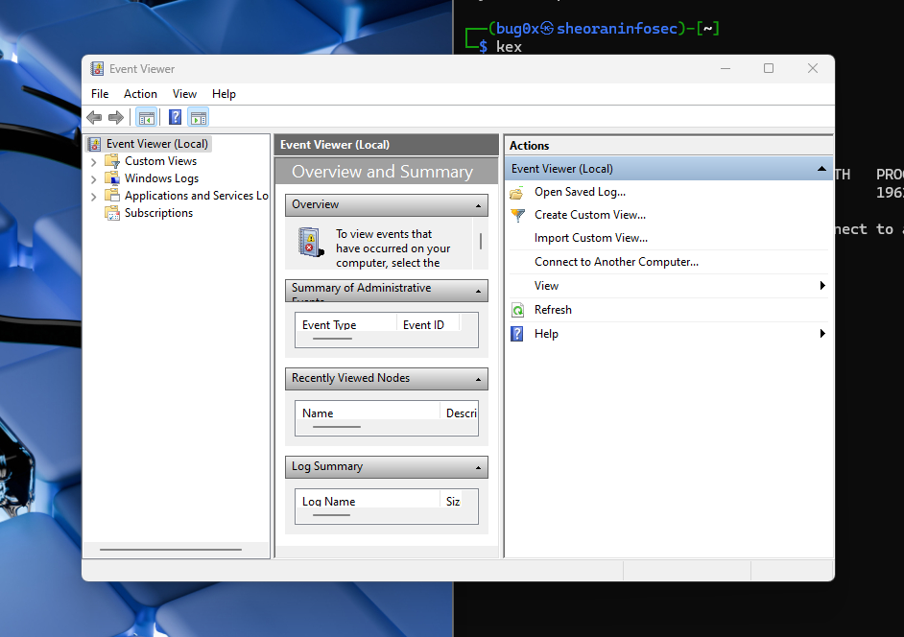

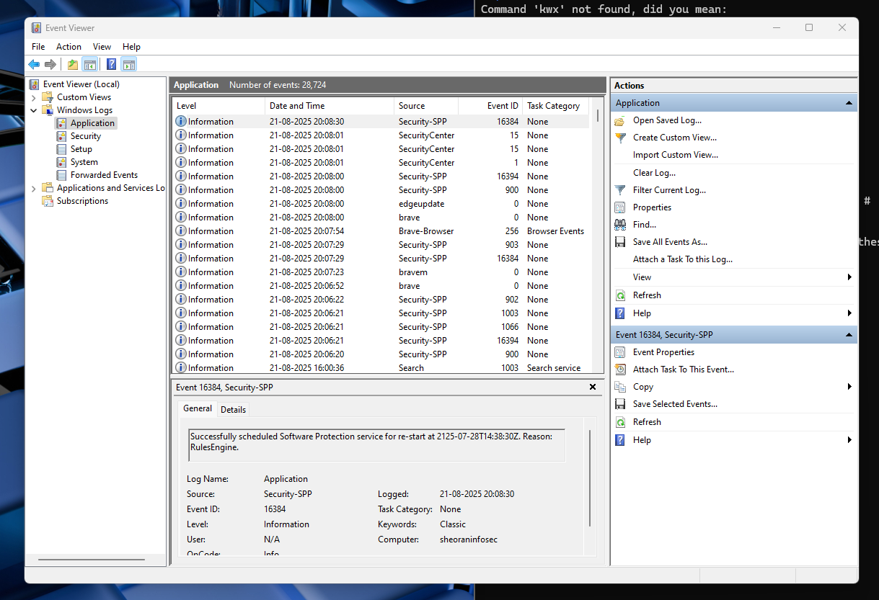

2. Event Viewers – Windows Logs

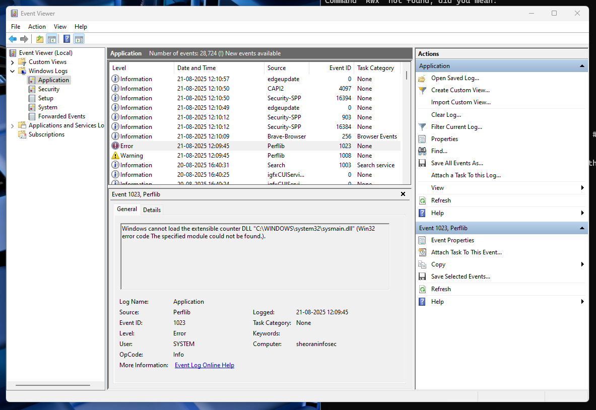

Example 2: Monitoring Security Events
- Expand Windows Logs and select Security.
- Look for events with Failure status. These might indicate unauthorized access attempts.
- Double-click the event to see details like source, user involved, and the specific action attempted.

3. Event Properties. -WARNING
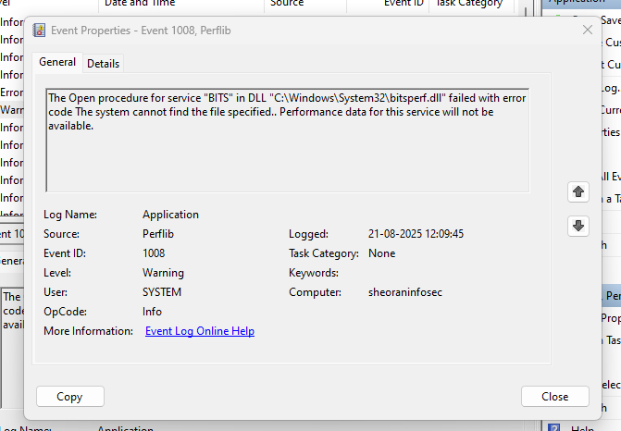
4. Event Properties – ERROR
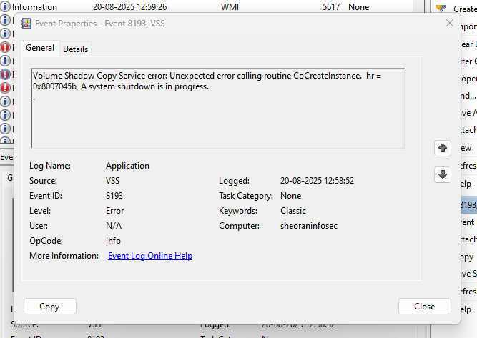

- Linux OS Logs
System processes, applications, and security tools running on Kali create log messages. These messages are sent to ‘rsyslog’, which activates based on its configuration. rsyslog can filter out irrelevant messages and apply formatting to make logs easier to understand. Logs can be directed to local files on the Kali system itself or forwarded to a remote logging server for centralized management. Rsyslog (Rocket-Fast System for Log processing) is a powerful and versatile message logging utility for Linux distributions, including Kali Linux, offering significant advantages over the traditional `syslogd` daemon.
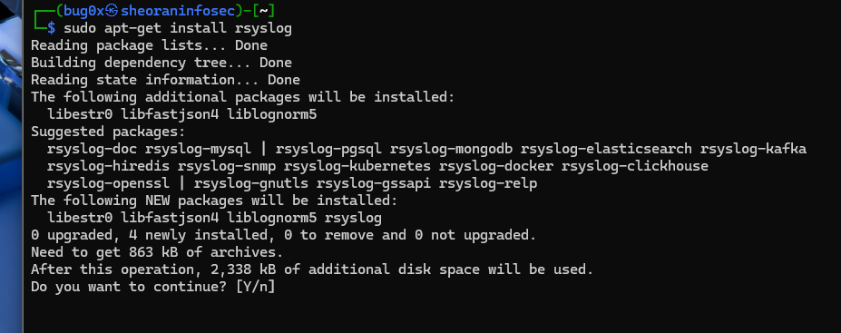

cd /var/log : ls -l
sudo apt install -y vsftpd
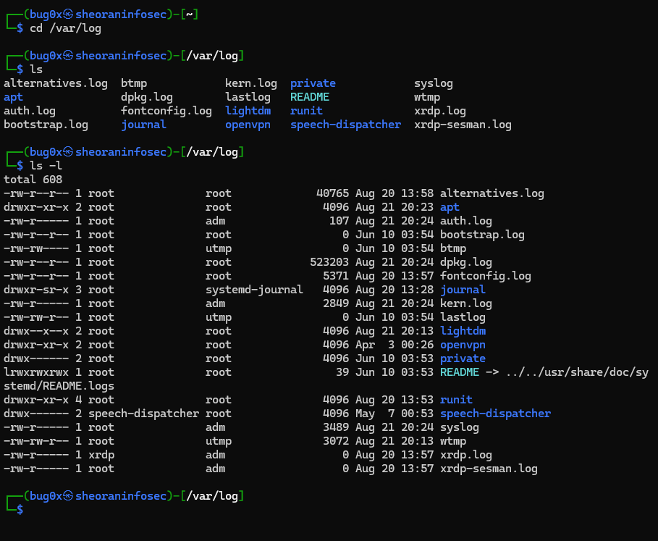

Use Case 1: Identify Login Attempts
Step 1: Use the command `grep Client vsftpd.log.1` in the terminal window. This searches the vsftpd application log for lines containing "Client" (indicating access and login attempts).
Step 2: Analyze the output to view timestamps, usernames, and if login attempt was successful or failed.
Step 3: We can also check for login or failure in ‘auth.log’ file
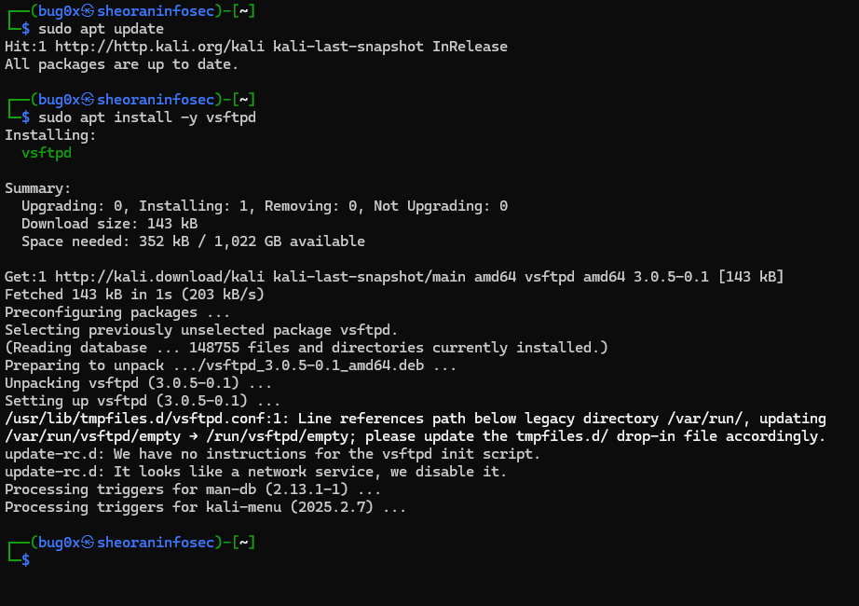
sudo systemctl start vsftpd
sudo system enable vsftpd
sudo systemctl status vsftpd
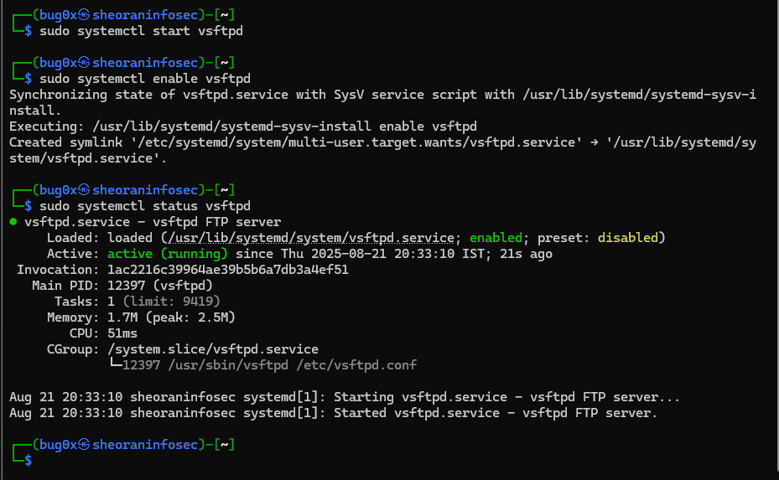

Use Case 2: Check User Login Management
Step 1: Use ‘sudo grep login boot.log’ in the terminal window to determine user logins

sudo nano /etc/vsftpd.conf
sudo service vsftpd start
ftp localhost

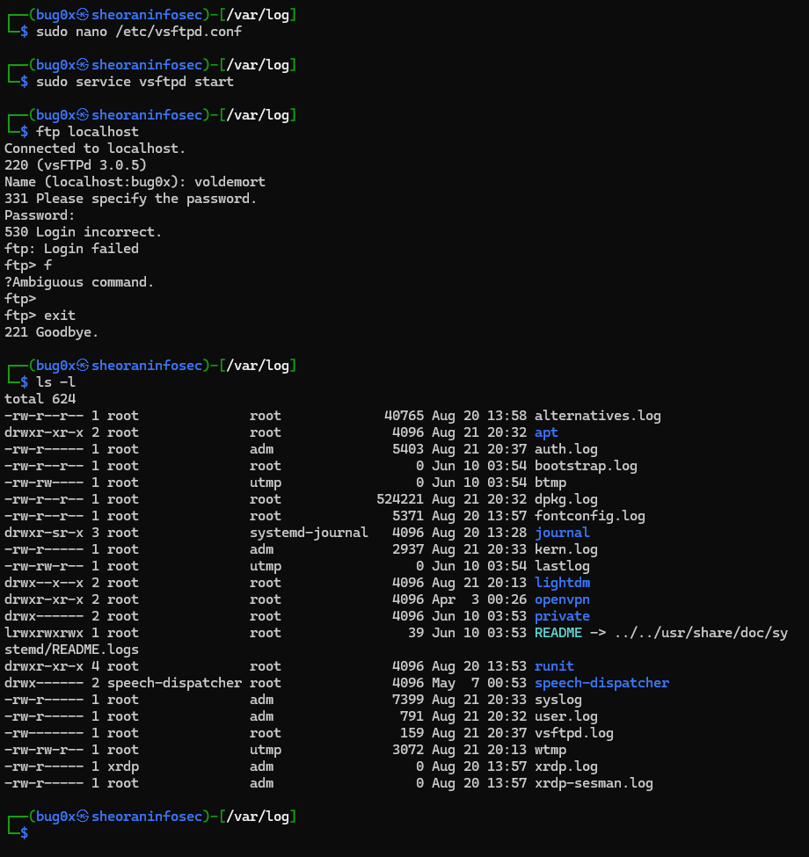

Use Case 3: Monitor System Activity (using `tail` and `/var/log/syslog`)
Step 1: Use the command `tail -f /var/log/syslog` to display the last lines of the system log file.
Step 2: Watch the output for suspicious activity or error messages and press `Ctrl+C` to stop when done.

sudo tail -f /ver/log/syslog

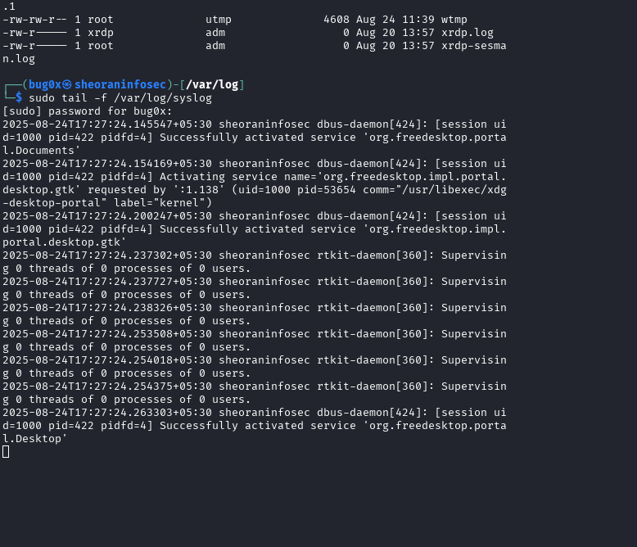

- Demo Event Log Dashboard
We have looked at RAW logs using OS utilities. Imagine 10,000 systems and their logs in an IT setup. These are accessed using a centralized dashboard by System Admins to search for events/incidents.
Step 1: Access the demo dashboard for Manage Engine Event Log Analyzer from https://demo.eventloganalyzer.com/event/index2.do?url=emberapp#/home/dashboard/301
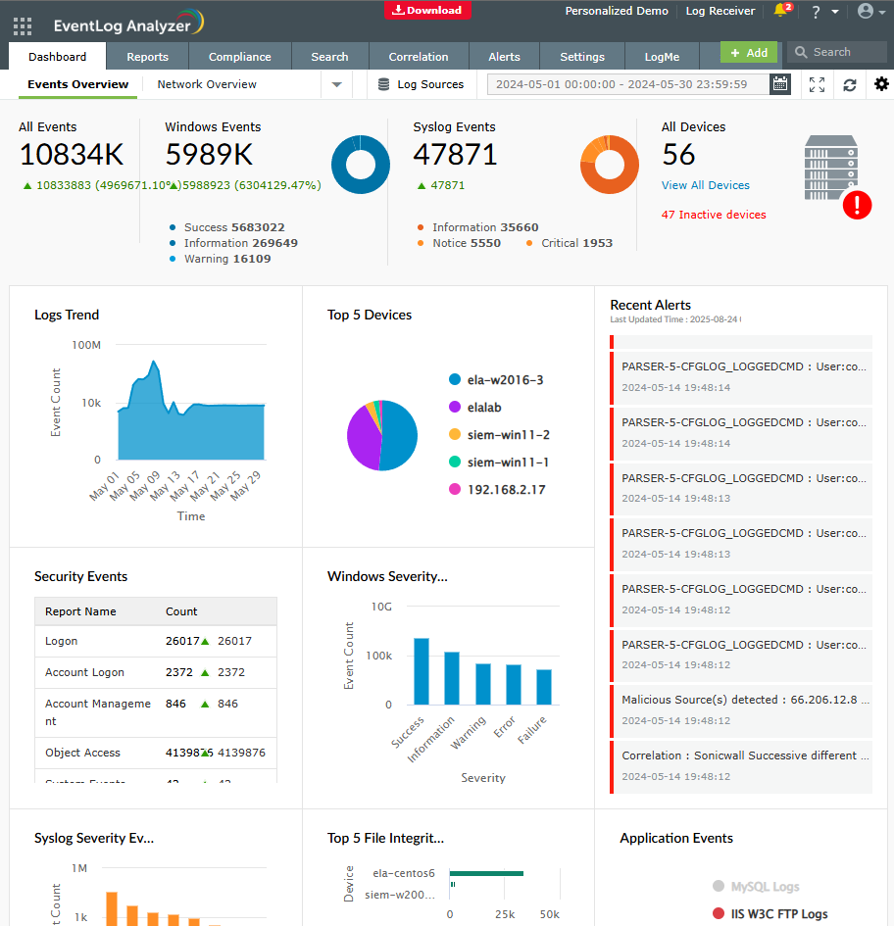

Step 2: This displays the commercial dashboard for Events, Trends, Severity Alerts for app/device logs
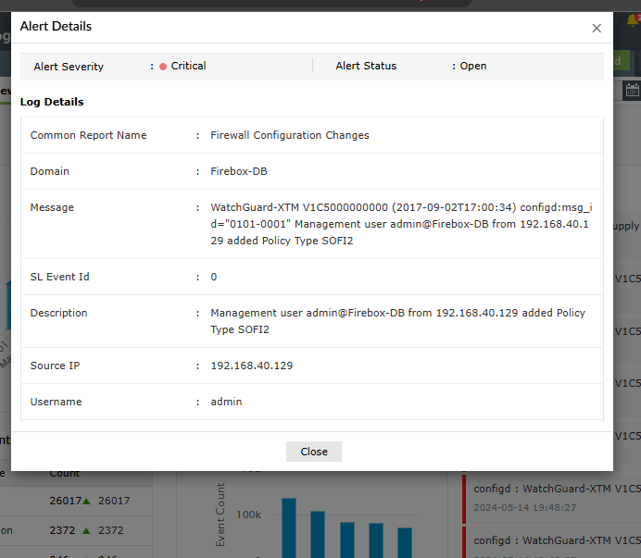

- Sample Web Log analysis
System Admins also perform Web Log analysis to gather information and intelligence.
Step 1: Study the sample web application log from https://www.weblogexpert.com/sample/index.htm

WEBSITE CLOSED PERMANENTLY

- Install Free Log Analyser
Graylog is a centralized logging solution that allows the user to aggregate and search through logs. It provides a powerful query language, a processing pipeline for data transformation, and alerting abilities.
Step 1: Download Graylog docker image in Linux from https://hub.docker.com/r/graylog/graylog
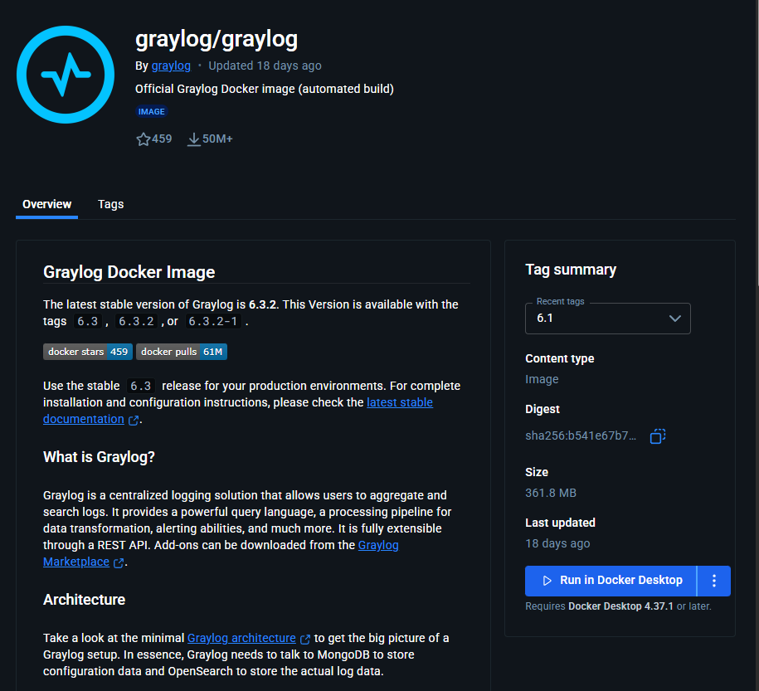

Step 2: Refer to the Graylog Docker documentation steps from https://go2docs.graylog.org/current/downloading_and_installing_graylog/docker_installation.htm
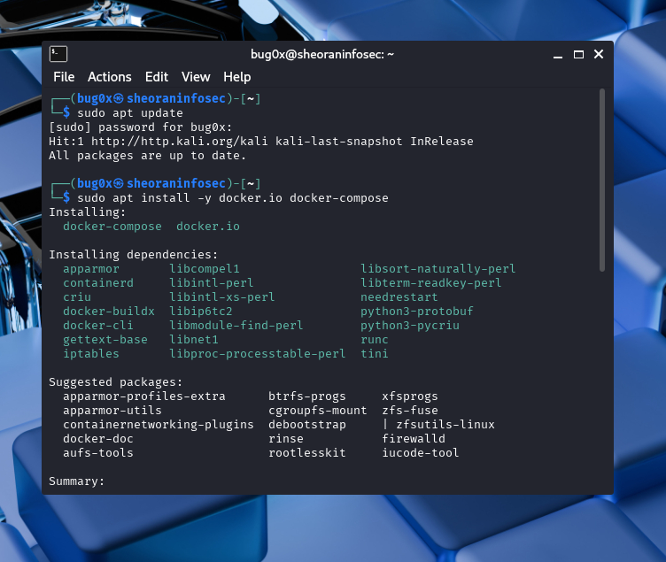

Step 3: Windows Event IDs: Refer to https://graylog.org/post/critical-windows-event-ids-to-monitor/ to study about Windows Event IDs.
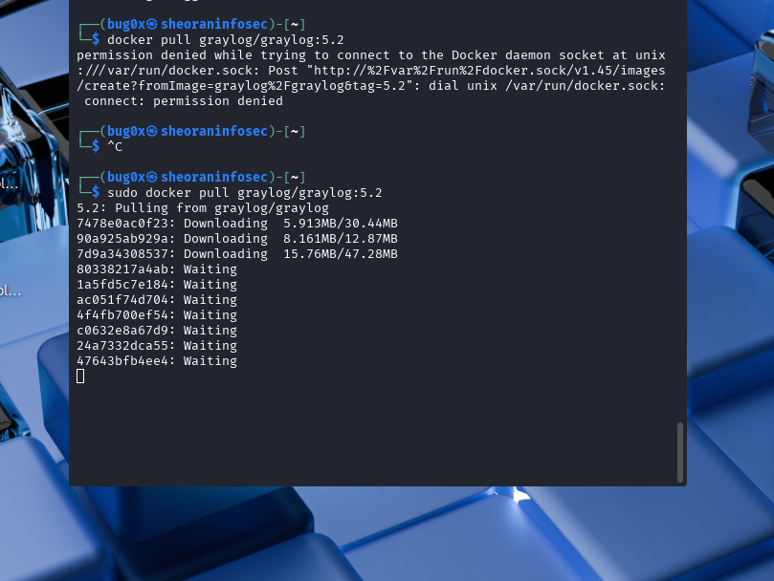

nano docker-compose.yml
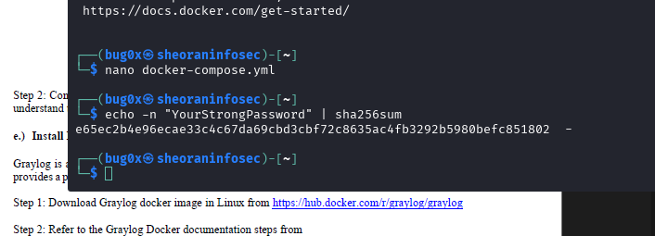

- Web Server - Apache
Step 1: Copy log samples for normal server functions from https://www.ossec.net/docs/log_samples/apache/apache.html#
1. LOGON EVENT:ID’S
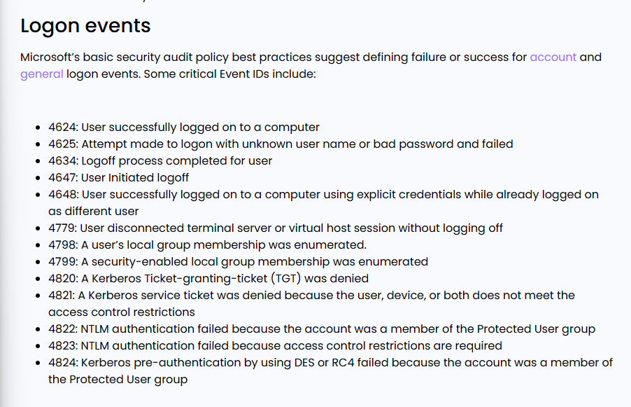
2. WINDOWS SERVER EVENT:ID’S
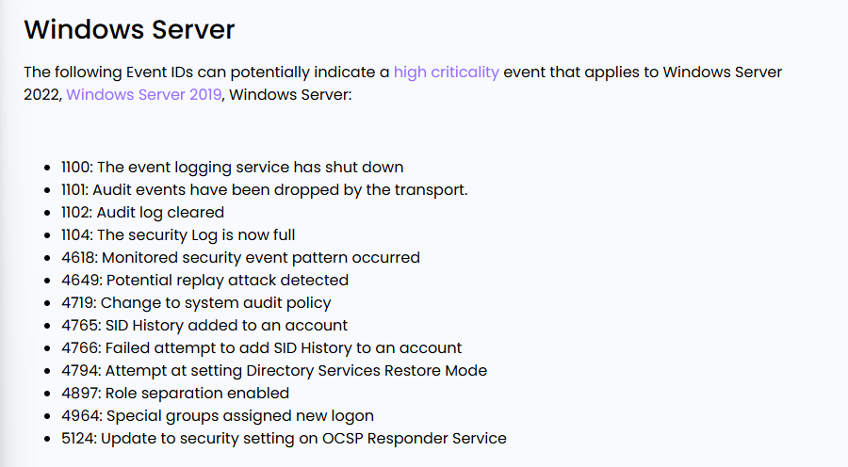

3. MICROSOFT DEFENDER EVENT ID’S
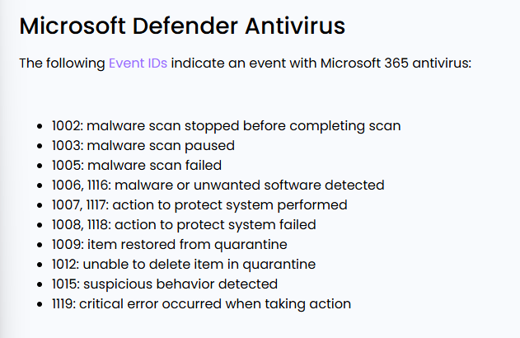

Name: Jigesh Sheoran
SAP ID: 590025428

